**Activity – phishing text message**

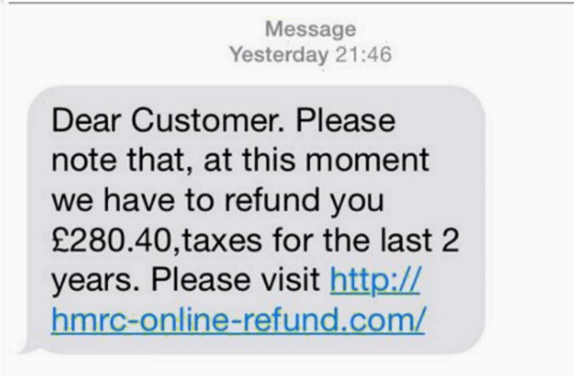

Give 3 reasons this text message is likely to be a phishing attempt.