[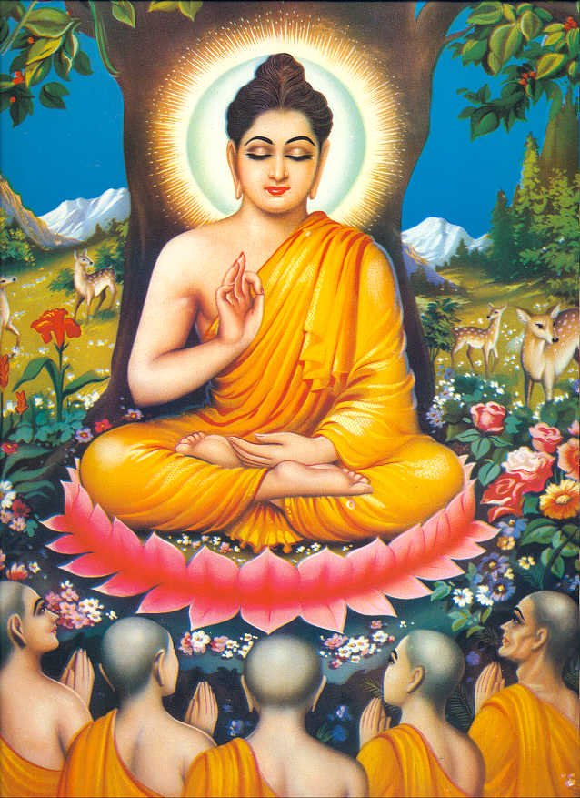](http://www.google.co.uk/url?sa=i&rct=j&q=buddha&source=images&cd=&cad=rja&docid=5ZZg8-oVjX_jDM&tbnid=HulR-jR6IpJY-M:&ved=0CAUQjRw&url=http://buddhaquotes.tumblr.com/&ei=I7kzUfK6IKen0AX6vYGgAg&bvm=bv.43148975,d.d2k&psig=AFQjCNG_FrcIAlinubNstx1corirxWaVmA&ust=1362430383114730)

**5 Moral Precepts**